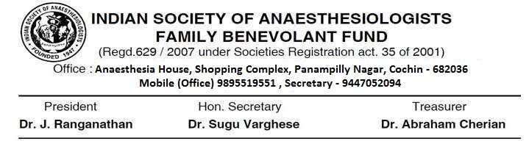

15-11-2018

ISA FBF - REPORT OF ACTIVITIES FROM 1ST DECEMBER TO 15TH NOVEMBER 2018

Total Number of Members – 2110

New Members Joined – 210

Voluntary drop outs – 4

Claims Issued

Name FBF No. Claim Amount Issued
1. | Dr Rajeendra Kumar N K | 1097/KE/103/2009 | 4,08,600
2. | Dr Ramani Koshy | 1173/KE/110/2010 | 4,08,600
3. | Dr Dandu Prasada Raju | 1305/AP/365/2010 | 4,08,600
4. | Dr Devarmani Prakasappa | 607/KA/15/2007 | 4,08,600
5. | Dr Sarojini Devanandan | 1232/TN/139/2010 | 4,08,600
6. | Dr. G Santhanam | 1851/TN/191/2017 | 4,08,600

Total No. of Deaths from 2000 to 2018 – 60

From 1st December onwards ISA FBF office tried its level best to focus on the problems of its existing members.

# updated their address & informed their dues from 2014 to 2018 by post, by repeated emails and repeated SMS alerts.
# By this way at present we are having only 157 defaulters.

Kerala – 2
West Bengal – 5
Bihar – 2
UP – 8
Rajasthan - 3
Assam – 1
Gujarat – 2
Haryana – 2
Himachal Pradesh – 1
J & K – 2
Punjab – 1
New Delhi – 9
Orissa – 11
MP – 9
Maharashtra – 17
Tamil Nadu – 10
Karnataka - 9
Andhra Pradesh & Telangana – 63

- As per the last GC discussions, those members having dues from 1st April will not be eligible for any claim from ISA FBF.
- All the details have been uploaded in the ISA FBF website www.isafbf.isaweb.in
- ISA FBF office tried it’s level best for the enrollemnt of new members.

New Membership

I am happy to inform you that it is the first time in the history of ISA FBF that a total of 210 new members joined this year.

UP – 3
Tamil Nadu – 7
Telengana – 4
Punjab – 1
Orissa – 3
Delhi – 1
MP – 2
AP – 33
Gujarat - 8
Karataka – 26
Kerala – 27
Maharashtra - 95

DFC 2018

Started sending due notice from 1st October onwards to all members by SMS, Email & Surface mail at regular intervals. By this way within a span of 45 days, 820 members paid their due amount.

Office

Our office had been shifted from Samaritan Hospital to Anaesthesia House, Panampilly Nagar, Cochin – 682036, Kerala.

Accounts

FD Balance - 1,09,43,638.00
Current A/C Balance - 4,50,708.77

Audited accounts will be presented by Dr. Abraham Cherian, Hon. Treasurer.

Thanking You

Yours faithfully.

Sd/-
Dr. Sugu Varghese
Hon. Secretary
ISA FBF

